Comp E 475

Microprocessors

HW7 : ALU module

Student: Giorgi Tchkoidze

Red ID #: 822089301

Contents

Task Description 2

Solution 2

Simulation & Verification 2

Comparison 3

Conclusion 3

# Task Description

*In this assignment, we have to implement ALU part of controller in verilog acording to following:*

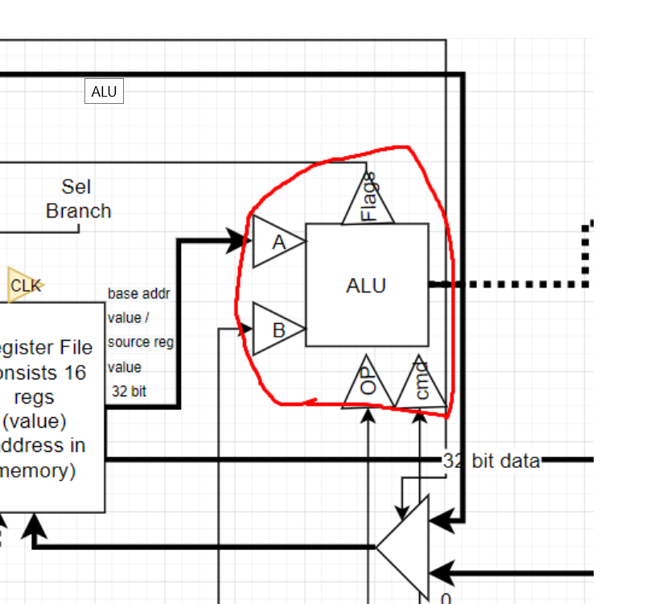

# Solution

*For ALU output we have to use combination of following inputs: “A”, “B” and “cmd”. To define output we can use multiplexer where cmd is selection signal.*

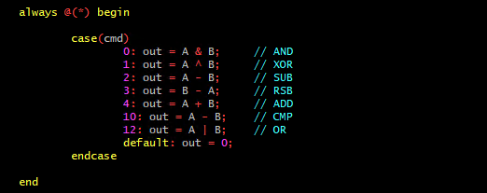

For flags:

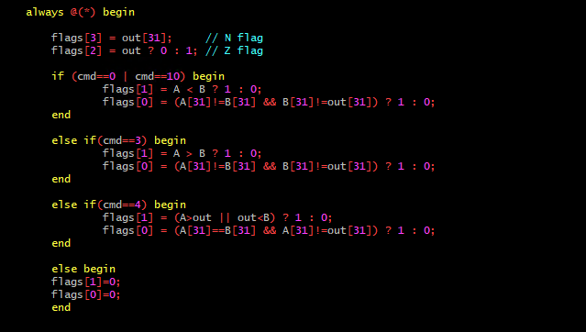

# Simulation & Verification

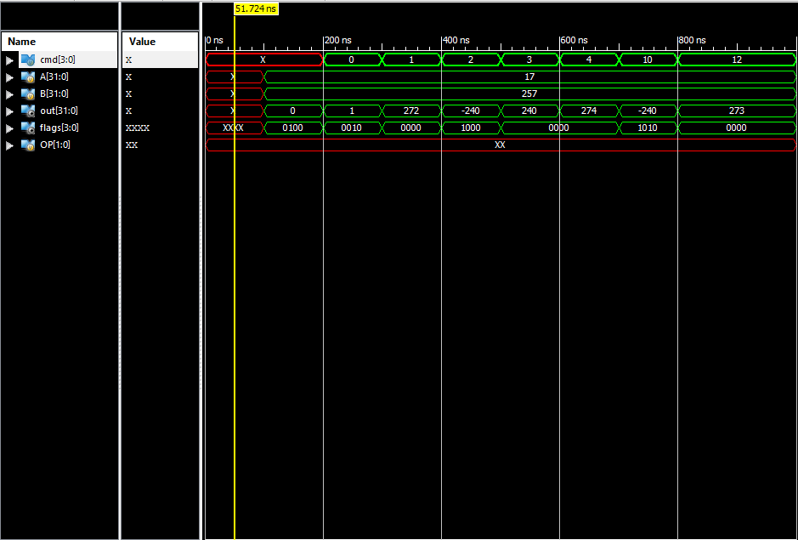

TestBench:

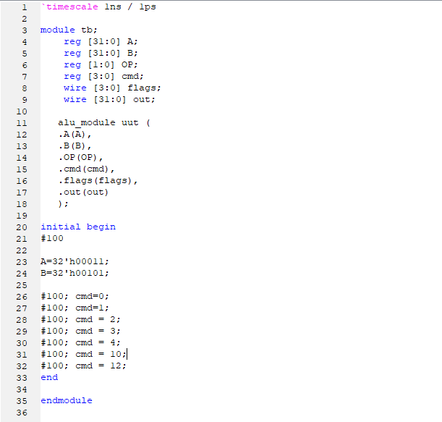

# Conclusion

In this assignment, I learned how ALU is making decisions based on inputs